SIMATS ENGINEERING
ASSESSMENT TOOL 1

COURSE NAME: Artificial Intelligence COURSE CODE: CSA17

COURSE OUTCOME COVERED
CO5: Design AI-based systems using PySpark, RDD operations, and intelligent agent architectures, using scalable systems and integrate components in distributed AI applications. (BTL 5)
Assessment Tool Weightage: 50%

QUESTIONS: 5
Duration : 1 Hour
Total Marks:50
Annexure A

Design Task

Code of Conduct:
I S.Chandra shekar (192372163) (Name / Reg No) certify that this submission is my original work and that I have adhered to the guidelines specified for this assessment.
I understand that any violation of academic integrity rules will result in disciplinary action.
Signature of the student:S.Chandra shekar

Annexure A

Design Task

1. Hybrid AI Recommendation Engine Design
Design a hybrid AI-based recommendation system that integrates content-based and collaborative filtering techniques using PySpark RDDs. Explain how distributed data processing can be used to handle large-scale user-item interactions, and describe the role of intelligent agents in adapting recommendations based on user behavior and feedback in real time.
2. Smart Disaster Detection System
Develop a distributed AI system using PySpark and RDD operations to detect natural disasters (such as floods or earthquakes) from multi-source data streams (satellite images, sensors, and social media). Describe the system architecture, data fusion techniques, and how intelligent agents coordinate to provide early warnings and response strategies.
3. AI-Based Fraud Detection Framework
Design a scalable fraud detection system using PySpark RDDs to process large volumes of financial transactions. Explain how anomaly detection algorithms can be implemented in a distributed manner and how intelligent agents collaborate to identify suspicious patterns, trigger alerts, and continuously improve detection accuracy.
4. Autonomous Supply Chain Optimization System
Construct a distributed AI system using PySpark for optimizing supply chain operations (inventory, logistics, demand forecasting). Describe how RDD transformations support large-scale data processing and how multiple intelligent agents interact to make decentralized decisions for cost minimization and efficiency improvement.
5. Personalized Learning Analytics Platform
Design an AI-driven educational platform that uses PySpark and RDDs to analyze student learning behavior and performance data. Explain how the system supports adaptive learning through intelligent agents, real-time feedback, and scalable analytics to personalize content delivery for thousands of learners.

ANSWERS

Each design below follows a common structure — architecture, PySpark/RDD processing strategy, and intelligent agent roles — so the scalable, distributed-AI design pattern used across all five systems is easy to compare.

Question 1: Hybrid AI Recommendation Engine Design
System Architecture
The system is organised into four layers: a Data Layer (user–item interaction logs streamed via Kafka, item metadata in HDFS/S3), a Distributed Processing Layer built on PySpark RDDs that computes content-based and collaborative-filtering scores in parallel, a Hybrid Fusion Layer that blends both scores, and an Intelligent Agent Layer that adapts and explains recommendations in real time.
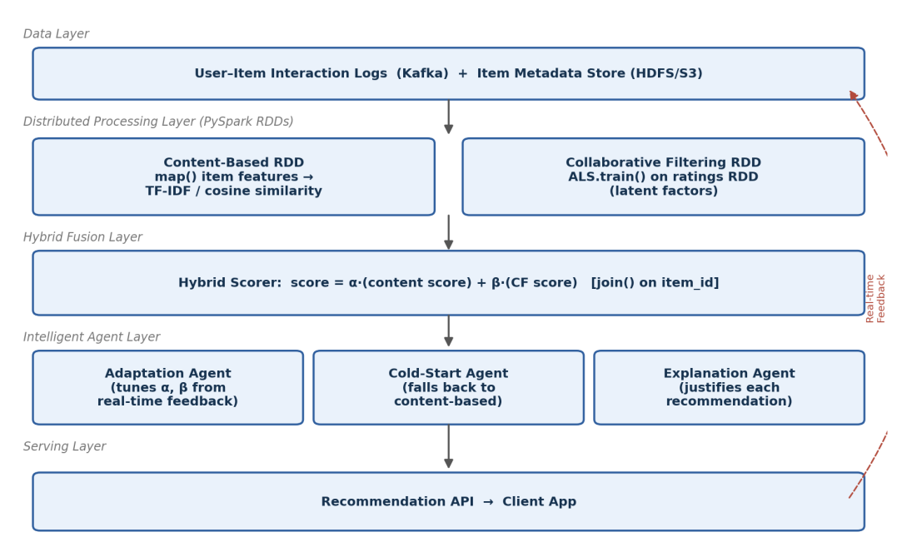
Fig. 1 – Hybrid recommendation engine architecture
Distributed Data Processing with RDDs
- Content-Based RDD – Item metadata is mapped into TF-IDF feature vectors; cosine similarity between items is computed with a Cartesian-style join restricted to candidate pairs, parallelised across partitions.
- Collaborative-Filtering RDD – The ratings RDD (user, item, rating) is partitioned by user and passed to Spark MLlib's ALS.train(), which factorises it into latent user/item matrices using distributed alternating least squares.
- Fusion – The two score RDDs are combined with join() on item_id, giving score = α·content_score + β·CF_score, so the workload scales horizontally as the user base grows.
content_rdd = items_rdd.map(build_tfidf_vector)
cf_model = ALS.train(ratings_rdd, rank=20, iterations=10)
hybrid_rdd = content_scores.join(cf_scores) \
.mapValues(lambda s: alpha*s[0] + beta*s[1])
Role of Intelligent Agents
- Adaptation Agent – Continuously observes click-through and dwell-time feedback and re-tunes the blending weights α and β so the system leans more on collaborative filtering as a user's history grows.
- Cold-Start Agent – Detects users/items with little or no interaction history and temporarily boosts the content-based score to avoid the cold-start problem.
- Explanation Agent – Surfaces the dominant reason behind each recommendation (e.g., 'similar to items you liked' vs 'users like you also liked'), improving user trust and transparency.
Question 2: Smart Disaster Detection System
System Architecture
Three heterogeneous data streams — satellite imagery, sensor networks (seismic/water-level), and social media posts — are ingested through source-specific Kafka topics tagged with geo-cell and timestamp metadata, then processed by parallel PySpark RDD pipelines before being fused into a single event-confidence score.
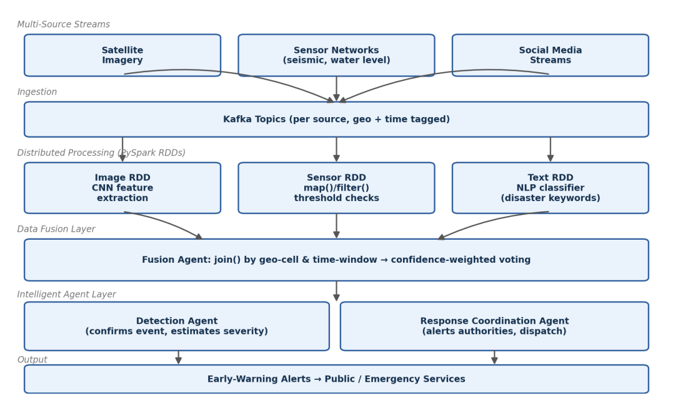
Fig. 2 – Multi-source disaster detection and data-fusion pipeline
RDD-Based Processing per Source
- Image RDD – mapPartitions() applies a lightweight CNN feature extractor to image tiles in parallel across executors, flagging visual anomalies (e.g., flood extent, structural damage).
- Sensor RDD – map()/filter() transformations apply threshold rules (e.g., seismic magnitude, rapid water-level rise) directly on the streaming micro-batch RDD.
- Text RDD – An NLP classifier (applied via map()) scores social-media text for disaster-relevant keywords and sentiment/urgency.
Data Fusion Technique
The three per-source RDDs are joined by (geo_cell, time_window) key, and a confidence-weighted voting scheme combines their individual scores — weighting sensor data highest (most reliable), imagery second, and social media as a fast-but-noisy corroborating signal. This union+join fusion runs as a single distributed Spark stage, so new geo-cells simply add more partitions rather than more sequential work.
Coordination of Intelligent Agents
- Detection Agent – Confirms an event once the fused confidence score crosses a severity-dependent threshold and estimates affected area/severity from the fused features.
- Response Coordination Agent – Converts a confirmed detection into an early-warning alert, routes it to the relevant emergency-response authority, and recommends evacuation/response zones based on the geo-cell footprint.
The two agents communicate asynchronously so that low-confidence detections can be held for corroboration from a second source before an alert is issued, reducing false positives.
Question 3: AI-Based Fraud Detection Framework
System Architecture
Financial transactions arrive continuously via Kafka and are processed in PySpark Structured Streaming micro-batches. Each batch RDD is converted into per-transaction feature vectors, aggregated per account, scored for anomalies, and routed to an alerting/investigation layer — with a feedback loop that lets the model keep improving from analyst decisions.
Distributed Anomaly Detection
- Feature Extraction – map() converts raw transactions into feature vectors (amount, merchant category, geo-distance from last transaction, time-since-last-transaction).
- Per-Account Aggregation – reduceByKey() aggregates rolling statistics (mean/variance of spend) per account across partitions.
- Anomaly Scoring – An Isolation-Forest / z-score model is applied with mapPartitions() so each executor scores its partition of transactions independently and in parallel, avoiding a data shuffle.
features_rdd = txns_rdd.map(extract_features)
acct_stats = features_rdd.map(lambda t: (t.acct_id, t)) \
.reduceByKey(update_rolling_stats)
flags_rdd = features_rdd.mapPartitions(isolation_forest_score)
Intelligent Agent Collaboration
- Detection Agent – Applies the trained anomaly model in real time and flags transactions above a risk threshold.
- Alert Agent – Immediately notifies the account holder / fraud desk for high-confidence flags and can place a temporary hold.
- Investigation Agent – Gathers related transactions and account history into a case file for human analyst review.
- Learning Agent – Feeds confirmed fraud/false-positive labels from analysts back into the training RDD, enabling periodic model retraining (active learning) so detection accuracy improves continuously without manual re-engineering.
Question 4: Autonomous Supply Chain Optimization System
System Architecture
Inventory, logistics, and demand data are ingested from ERP and IoT sources into PySpark, where RDD transformations join and aggregate these datasets by SKU and warehouse. Three specialised agents then use this processed data to make decentralized, cost-minimizing decisions that are periodically reconciled centrally.
RDD Transformations for Large-Scale Processing
- Inventory–Demand Join – join() combines inventory-level RDDs with demand-forecast RDDs on (sku, warehouse_id), producing a per-item, per-location state.
- Reorder Computation – mapValues() computes reorder points and safety-stock levels from the joined data in parallel across all SKUs.
- Regional Grouping – groupBy(region) partitions logistics data so routing optimization for each region runs independently and in parallel.
state_rdd = inventory_rdd.join(demand_forecast_rdd)
reorder_rdd = state_rdd.mapValues(compute_reorder_point)
routes_rdd = logistics_rdd.groupBy(lambda r: r.region) \
.mapValues(optimize_route)
Decentralized Multi-Agent Decision-Making
- Inventory Agent – Runs per warehouse; monitors stock levels against the computed reorder point and autonomously places replenishment orders.
- Logistics Agent – Optimizes delivery routes and vehicle loads within its region using the partitioned routing RDDs, minimizing transport cost.
- Demand-Forecasting Agent – Continuously updates demand predictions per SKU (time-series model) and shares them with the Inventory Agent.
Agents negotiate through a lightweight contract-net-style protocol — e.g., an Inventory Agent 'bids' a replenishment request that the Logistics Agent accepts if it fits an existing route — so decisions stay decentralized and scalable, with only periodic global reconciliation needed to catch systemic imbalances.
Question 5: Personalized Learning Analytics Platform
System Architecture
Clickstream events, quiz scores, video-watch data, and forum activity from thousands of learners stream into PySpark, where RDD pipelines build per-student engagement profiles. These profiles drive a set of intelligent agents that personalize content delivery and intervene when a learner shows signs of disengagement.
RDD-Based Processing
- Feature Construction – map() converts raw event logs into structured (student_id, feature_vector) pairs (time-on-task, quiz accuracy, video completion).
- Per-Student Aggregation – reduceByKey() aggregates session-level features into a rolling per-student engagement/performance profile.
- Segmentation & At-Risk Prediction – A K-Means model (trained across the full student RDD) groups learners into performance/engagement segments; a lightweight classifier flags at-risk students.
events_rdd = logs_rdd.map(parse_event)
profile_rdd = events_rdd.map(lambda e: (e.student_id, e)) \
.reduceByKey(update_profile)
segments = KMeans.train(profile_rdd.values(), k=5)
Intelligent Agents for Adaptive Learning
- Tutor Agent – Adjusts content difficulty and pacing in real time based on each student's rolling performance profile.
- Engagement Agent – Monitors engagement signals (drop in logins, incomplete videos) and sends timely nudges or alerts instructors.
- Content-Recommendation Agent – Suggests the next-best learning resource using the student's segment and recent performance, similar to the hybrid recommendation pattern in Question 1.
Because all profile-building and segmentation runs as distributed RDD/DataFrame operations, the pipeline scales horizontally simply by adding executors, allowing the platform to serve real-time, personalized feedback to thousands of concurrent learners without redesigning the pipeline.

RUBRICS FOR CALCULATION

Evaluation Criteria | Problem Understanding & Requirement Analysis | System Architecture Design | Use of PySpark & RDD Operations | Intelligent Agent Integration | Scalability & Distributed Computing Design | Data Flow & Processing Pipeline | Innovation & Creativity | Clarity, Presentation & Documentation
Weightage | 10% | 20% | 15% | 15% | 10% | 10% | 10% | 10%

Criteria | Excellent (5) | Good (4) | Average (3) | Poor (2)
Problem Understanding & Requirement Analysis | Clearly defines problem, objectives, and constraints | Mostly clear with minor gaps | Basic understanding | Unclear or incorrect
System Architecture Design | Complete, scalable, well-structured architecture with diagrams | Good design with minor issues | Basic design, lacks detail | Poor/incomplete
Use of PySpark & RDD Operations | Efficient and correct use of RDD transformations/actions | Mostly correct usage | Limited or partial use | Incorrect/missing
Intelligent Agent Integration | Strong integration with clear agent roles and logic | Good integration | Basic integration | Poor/no integration
Scalability & Distributed Computing Design | Clearly addresses scalability, fault tolerance, parallelism | Covers most aspects | Limited consideration | Not addressed
Data Flow & Processing Pipeline | Clear, logical, and well-defined data flow | Mostly clear | Some gaps | Poorly defined
Innovation & Creativity | Highly innovative, realistic, and impactful solution | Some innovation | Basic idea | No originality
Clarity, Presentation & Documentation | Very clear, neat diagrams, well-organized report | Mostly clear | Somewhat organized | Poor presentation

